**UOG, Tokyo University tests a virus from Palau on Guam’s rhino beetles**

A team of scientists and students from the University of Guam, the Tokyo University of Agriculture & Technology (TUAT), and Palau Community College (PCC) are investigating whether a virus that was introduced to control coconut rhinoceros beetles in Palau can be used to control rhino beetles in Guam.

The coconut rhinoceros beetle (CRB), an invasive species found in Guam in 2007, has been in Palau since World War II. About 50% of Palau’s coconut palms had been killed when, in the 1960s, a virus that infects only rhino beetles was discovered and released in Palau and on many other Pacific islands that had been invaded by CRB. Wherever the virus was released, CRB populations and their resulting damage were greatly reduced.

The rhino beetle virus was released in Guam in 2009 with the expectation that it would have the same effect. Unexpectedly, nothing happened. It was later discovered that the Guam CRB population is genetically different from other CRB populations, and lab tests show that this genotype, referred to as CRB-G, is resistant to the rhino beetle virus.

“We’re trying all kinds of different strains of the virus hoping to find one that matches our beetle,” said Dr. Aubrey Moore, an entomologist with UOG Cooperative Extension & Outreach. “The one we’re testing now is from Palau. It doesn’t seem to kill our beetles, but we’re wondering if there are some sublethal effects. That would be really important. You don’t have to kill an insect to control it. If you can stop it from feeding or flying or reproducing, that will reduce its damage.”

**A Pacific-wide effort**

Since CRB-G invaded Guam in 2007, it has also invaded Palau, Papua New Guinea, the Solomon Islands, Oahu, and Rota in the Northern Mariana Islands. Outbreaks on these islands are causing major damage to coconut palms and oil palm crops. UOG is part of a Pacific-wide ad-hoc group of researchers — including Palau Community College, University of Hawaii, and universities in Australia, New Zealand, Fiji, and the Solomon Islands — who are actively working to find new isolates of the rhino beetle virus that will infect CRB-G.

Funding from a U.S. Forest Service grant and a Department of the Interior Office of Insular Affairs grant as well as a new student exchange agreement signed this year between the UOG College of Natural & Applied Sciences and TUAT are supporting the current collaborative research at UOG.

The research team consists of Moore, Christian Cayanan, Laura Caser, Leahmarie Bukurou, and Raimunt Mesubed at UOG, Dr. Madoka Nakai and Mayuho Yamauchi at TUAT, and Dr. Christopher Kitalong at PCC.

Yamauchi is the first exchange student of the CNAS-TUAT partnership. Prior to beginning a Ph.D. program focused on CRB at TUAT this fall, she spent this past March in Guam designing lab experiments with Moore and collecting data. Her adviser, Nakai, is an insect virologist who has been visiting Guam and working with UOG for the past 10 years to find a biological control agent for the CRB population in Guam.

**‘No guarantee’**

The experiment involved feeding banana mash with the virus to a group of CRB-G adults and feeding banana mash without the virus to an experimental control group. Each beetle was laser engraved with a unique number and was observed daily to record mortality, food consumption, flight activity, and reproduction rates.

“There’s no guarantee that this Palau strain is the one we’re looking for. We’re hoping it is because the damage in Palau is much, much less than here,” Moore said.

From their initial observations of the beetles over several weeks, the strain didn’t appear to have much effect on their behavior.

The next step is to dissect each beetle to obtain a gut sample that Yamauchi will then test at a lab at TUAT to see which, if any, beetles were infected with the virus. The activity and data records of the infected beetles will be compared with that of the uninfected beetles to see if they behaved differently or died sooner.

Moore said it will most likely be a form of this virus that will be the solution for reducing the CRB-G populations. He said there are about 25 isolates of the virus to be tested or retested, with the next promising candidate being an isolate from the Philippines. Moore expects to begin an experiment with that strain in the coming months.

“This is pure guesswork,” he said, “But I am hoping my lab or somebody else’s lab will find a good biocontrol candidate for CRB-G.”

**PHOTO CAPTIONS**

UOG entomologist Dr. Aubrey Moore shows a laser-engraved number on a coconut rhinoceros beetle. The numbers allow him to track individual beetles’ behavior to see if and how they’re affected by a particular strain of rhino beetle virus.

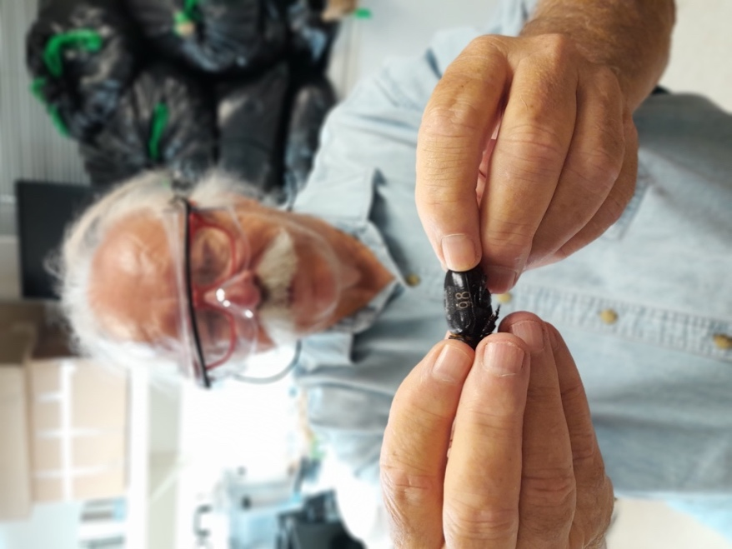

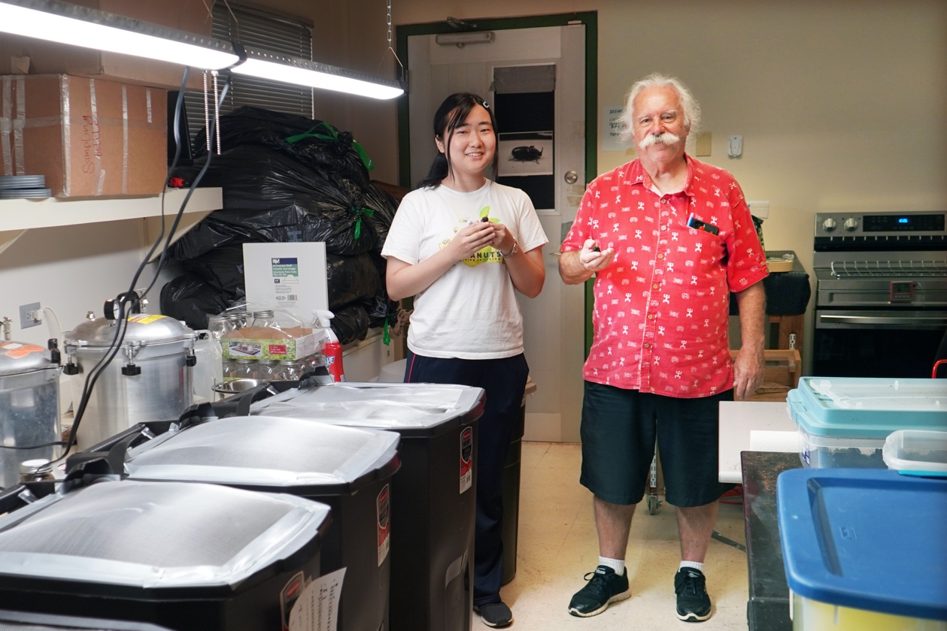

Mayuho Yamauchi, a graduate exchange student from Tokyo University of Agriculture & Technology, and University of Guam entomologist Dr. Aubrey Moore stand by containers they’ve outfitted to test the effect of a virus on rhino beetles’ ability to fly.

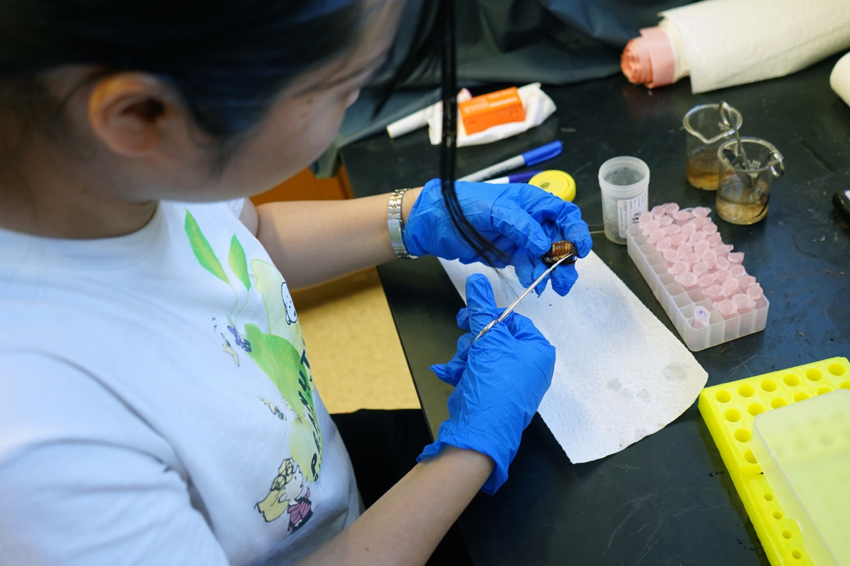

Mayuho Yamauchi, a graduate exchange student from Tokyo University of Agriculture & Technology, dissects a Guam rhino beetle. She will be testing gut samples of beetles that were fed a virus to see if they were successfully infected.

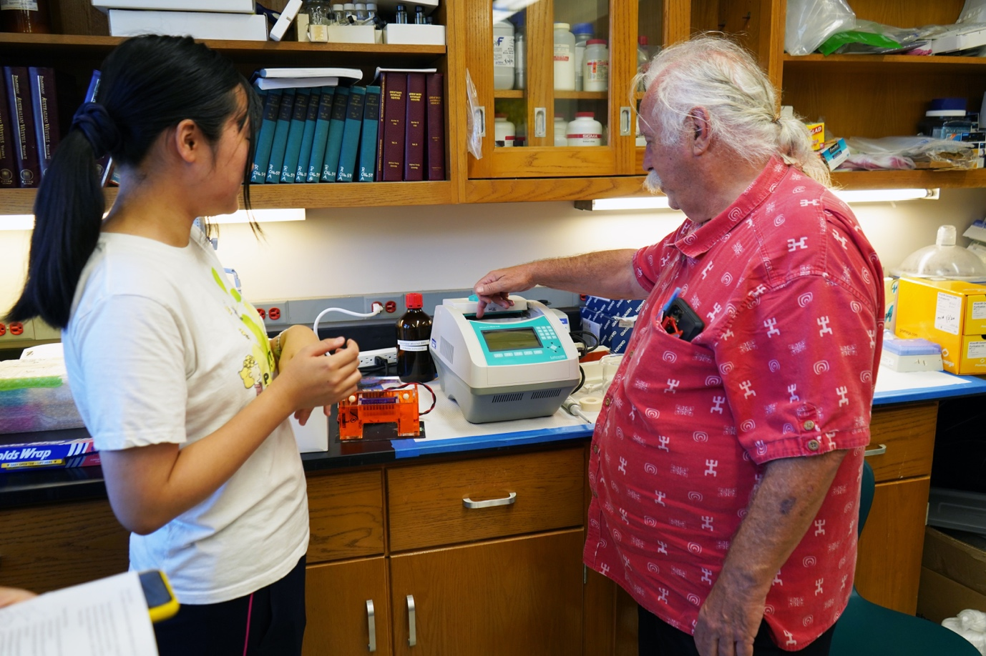

Mayuho Yamauchi, a graduate exchange student from Tokyo University of Agriculture & Technology, and University of Guam entomologist Dr. Aubrey Moore use a spectrophotometer to measure the feeding rate of rhino beetles.